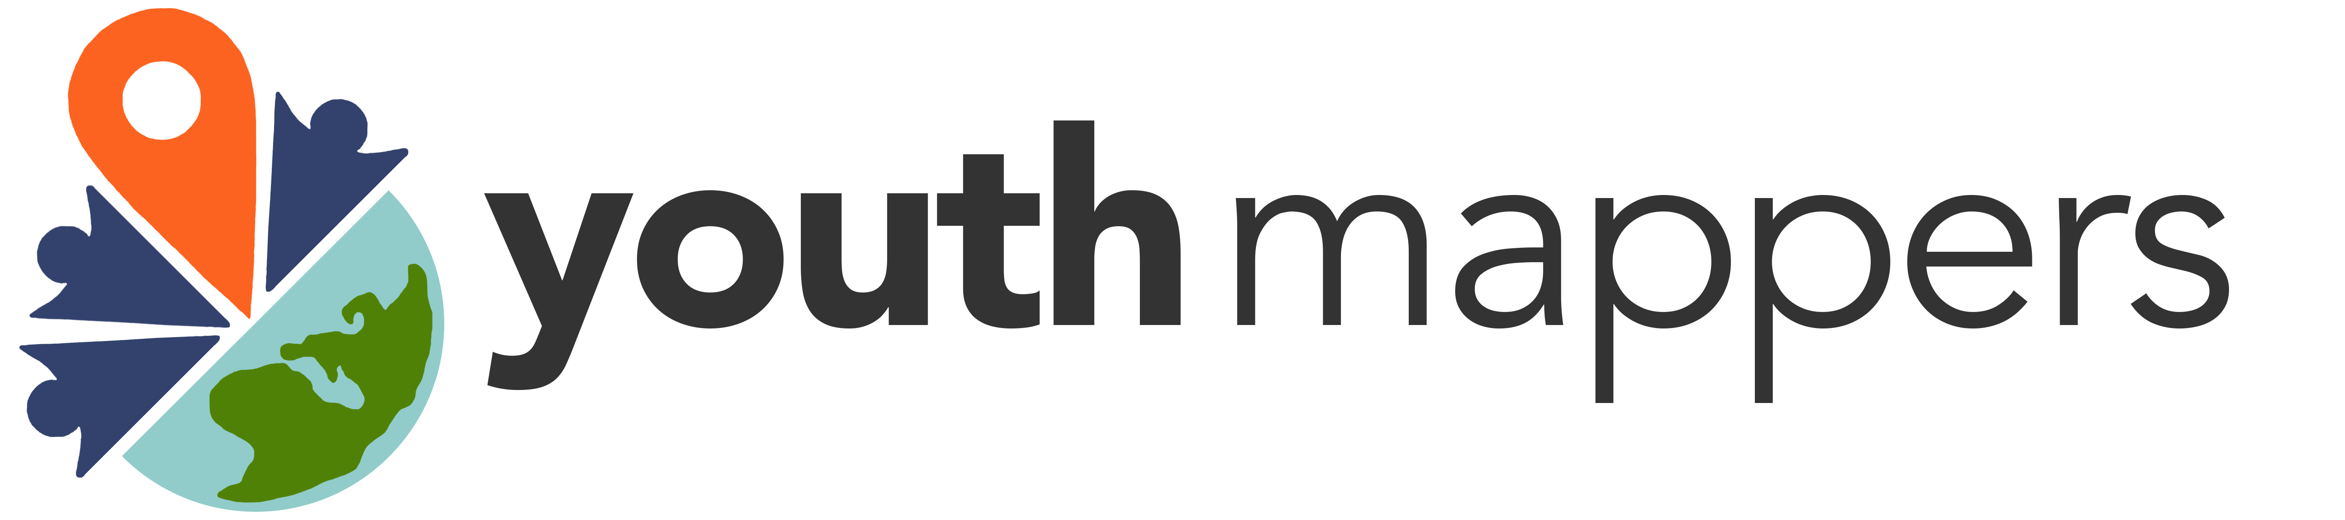

Memorandum of Understanding between
The Open Source Geospatial Foundation
and
YouthMappers

The purpose of this Memorandum of Understanding (MOU) is to establish a collaborative relationship between the Open Source Geospatial Foundation (OSGeo) and the YouthMappers. Both parties to this MOU share the goal of helping share global geo-information and geoeducation opportunities with all communities .

The MOU will cover the following proposals and topics:

- GeoForAll will encourage labs to establish YouthMappers chapters to expand students links with the Open Source geospatial community.

- GeoForAll will proactively work to identify ways for student travel support for FOSS4G events and promote such funding in the future for students explore creative ways to have local or nearby chapters participate without registration costs (as conference assistants, etc.)

- GeoForAll will help YouthMappers to identify any competitions or internship opportunities for YouthMappers within the OSGeo ecosystem.

- YouthMappers will include GeoForAll resources on their wiki for their chapters and promote use of them by participating universities.

- YouthMappers advertise FOSS4G events to YouthMappers chapters, especially to local chapters, along with any travel support that might be available.

- YouthMappers will help with any competition (recruitment, selection, nominations, etc.) processing that GeoForAll might offer benefits for such as conference assistants, etc.

- GeoForAll will work to encourage webinars from YouthMappers community in the GeoForAll webinar series to give more students platform to share their work. YouthMappers will add any YouthMappers-given GeoForAll webinars to their YouTube channel

- GeoForAll will highlight and promote the work of YouthMappers leaders in GeoForAll newsletters, website, etc.

This MOU will be reviewed biennially by both parties at which time revisions may be made and the agreement renewed.

Signed on 25 July 2018 in Milan, Italy by

____________________________________ ________________________________
Maria Antonia Brovelli, PhD Patricia Solís, PhD
Director, OSGeo CoFounder and Director
YouthMappers

